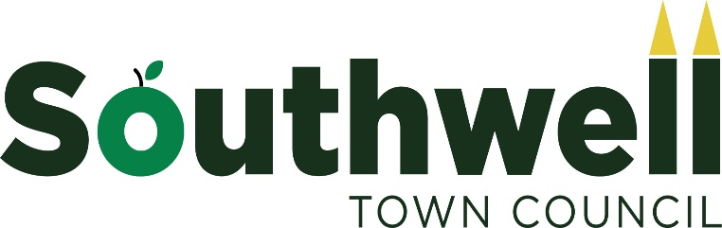

The Town Council is committed to transforming Southwell into a cleaner, greener town making it a more pleasant place to live and work for everyone. The objective is to encourage Southwell to become a zero-carbon town by 2030 - with a high quality built and natural environment as well as a healthy and active population.

A. Strategic Action
A.1. Southwell Town Council notes that:
- Local Government has a role to play in responding to the Climate Change Act; [ref i];
- 205 UK Councils have declared a climate emergency and radical action, [ref. ii];
- Southwell’s position as a national tourist destination puts us in an influential position;
A.2. Southwell Town Council agrees to:
- Declare a ‘Climate Emergency’ and communicate this widely;
- Ensure that all Council policy proposals consider the impacts of climate change and its mitigation;
- Investigate funding opportunities for action to improve environmental performance;
- Take local action to contribute to national carbon neutral targets through the development of Southwell Town Council’s practices and policies;
- Lobby all relevant bodies to ensure that all development in Southwell includes measures to minimise environmental emissions;
- Lobby for improved and integrated public transport;
- Work with our residents, businesses, organisations and environmental groups to raise awareness and change behaviours;
- Develop a communication strategy to convey to the community the severity of the situation;
- Adopt ethical purchasing and investment practices

B. Southwell Town Council will focus on SMART Goals [ref iii] for the following:
B.1. Becoming a Zero Carbon Council by:
- Reviewing the environmental performance of our land and properties and improving them;
- Using “green” electricity in council property;
- Minimising energy and water usage across the Council’s estate;
- Supporting the adoption of sustainable technologies where possible;
- Optimising the fuel used by vehicles on Council business;
- Replacing our vehicles with ULEV ones as soon as economically possible;
- Reducing waste, recycling where possible and minimising the use of paper and single-use plastics in our work;

B.2. A Quality Built and Natural Environment by:
- Revising the Southwell Neighbourhood Plan to set higher energy requirements than those currently contained within Part L of the Building Regulations for new houses, extensions, conversions and changes of use as advised by the Committee on Climate Change;
- Enhancing the quality, extent and accessibility of Southwell ’s open space including re-wilding appropriate areas;
- Reviewing the layout and condition of our highways, footpaths and cycleways and to recommend improvements to their condition and accessibility to the Highway Authority to minimise carbon emissions;
- Planting trees in appropriate areas to offset the carbon produced by Southwell’s homes;

B.3. Influencing others by:

Encouraging the use of public transport, cycle routes and footpaths;

Encouraging our community to minimise fossil fuel use;

Encouraging our community to install renewable and low carbon energy sources;

Encouraging our community to minimise waste by Reducing, Reusing, Recycling and Composting, with a focus on minimising single-use plastics
- Encouraging our community to buy Fairtrade and locally grown food, and less new clothes and shoes;
- Encouraging our community to reduce meat consumption and eat more vegetables and fruit;

Supporting the traders to avoid plastic packaging and to use recyclable wrapping;

C. Accountability
- Southwell Town Council will develop a workable Implementation Plan with details of actions, targets and funding implications and keep it under review;
- Southwell Town Council will only implement items in this policy when they are adequately resourced;
- Southwell Town Council will monitor compliance with this Policy and review it as necessary;
- Southwell Town Council will publish this Policy on its website;

