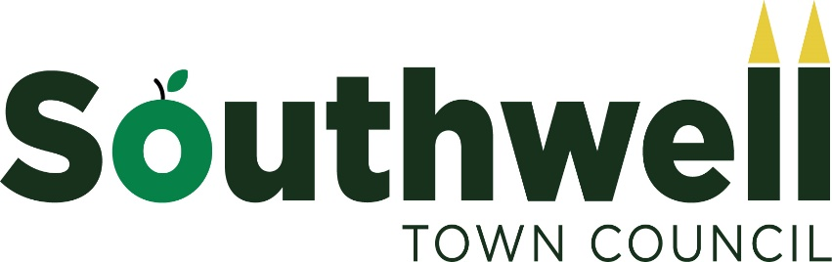

Banner on the Burgage Policy

- The Town Council has a banner support (size 10ft by 3ft.) which is located at the Station Road end of the Burgage.

- Use of the banner position is for community and/or charity events or promotion of Southwell as a tourist destination.

- Permission must be sought at least 6 weeks in advance by contacting the Town Council office 01636 816103 or by emailing admin@southwell-tc.gov.uk.

- The exact dates requested for a banner to be displayed must be stated at the time of booking.

- The maximum amount of time allowed for the display of any banner is 2 weeks.

- Some weeks in the year are booked on an annual basis and these relate to the major annual events in the town.

- Town Council Staff can put the banner up on behalf of organisations. If this is requested, the banner needs to be supplied to the Town Council 3 days before the date booked.

- The banner must be removed from The Burgage by the organisation which has booked it the day after the event.

- The Town Clerk has final say on all requests for banner placements.

