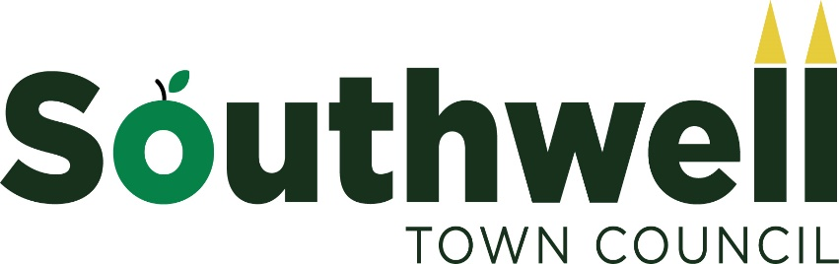

VOLUNTEER POLICY

This policy sets out the principles for voluntary involvement in activities authorised by Southwell Town Council.
The council acknowledge that volunteers contribute in many ways, and that volunteering can benefit the council, local communities and the volunteers themselves.
This policy applies to volunteers working on behalf of the town council, not those employed by the council or members of the council.
Volunteers shall be required to note that only volunteer work that has been authorised by the council will be covered by the council’s insurance. The council may decide to set-up a volunteer database that records volunteers and some basic contact details.
Volunteer activity
1. Volunteers must inform the event supervisor (The Town Clerk or a person appointed to the role by the Clerk) of work they intend to carry out before commencing such work. This can be in writing via e-mail to the Town Clerk or by signing in ahead of a session. The record will be retained.
2. Volunteers must be adequately trained to be able to carry out the role or activity they are undertaking. The exact nature of the training will depend on the role or activity and the findings from the required risk assessment.
3. A risk assessment will be undertaken by the event supervisor in order to identify any risks that might be faced and how they will be managed. The risk assessment will have regard to any safeguarding arrangements.
The Town Clerk is to receive a copy of the risk assessment ahead of work being undertaken. Visual inspections of the work area must be carried out and recorded prior to work commencing. The risk assessment should include as a minimum
- The job or activity
- The existing competency of volunteers
- The circumstances of the work (eg the degree of supervision)
- The tools and/or equipment being used
- Training requirements
The training standard must be sufficient to ensure the Health and Safety of volunteers and any people who might be affected by the work.

4. Volunteers must be informed about the task and its purpose, health, safety and supervision arrangements. Responsibility for this rests with the event supervisor to whom authority has been provided by the town council.
5. All volunteers shall have regard to the Health & Safety at Work Act 1974 when undertaking work. Volunteers will not be authorised to carry out work that the Council considers hazardous or would contravene the principles of the Health and Safety at Work Act 1974, taking into account the competence of the volunteer(s) carrying out the proposed work.
6. All volunteers must have due regard to the fact that they are carrying out authorised work on behalf of Southwell Town Council and as such are representing the Council, both in quality of work and possible interaction with the public.
7. A copy of this policy will be provided to all volunteers. Email copies must be electronically signed and returned to the Town Council from the volunteer’s email address.
8. Large groups of volunteers must sign a register stating they have seen a copy of this policy.

_________________________ [Print name],
Volunteering for Southwell Town Council, acknowledge that I have read, accept and adhere to the Volunteer Policy.

