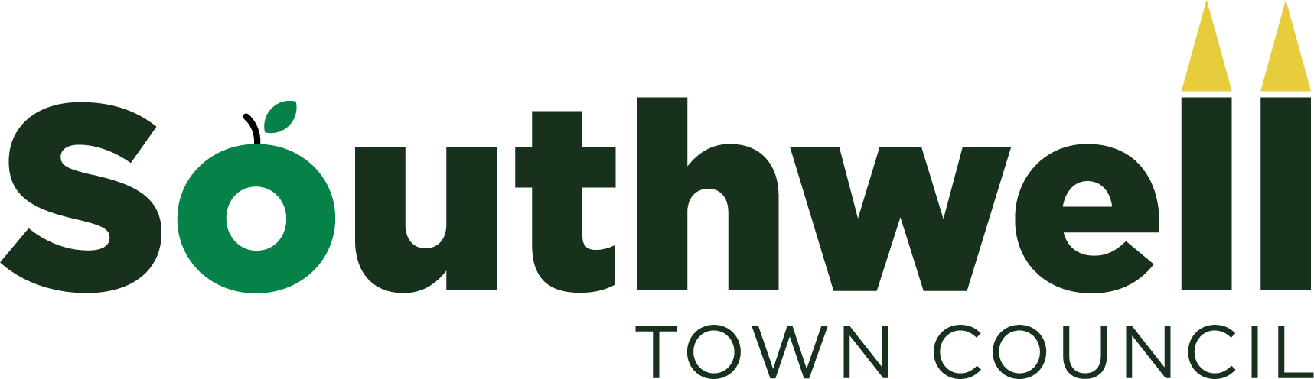
Provision of Markets in Southwell
Part 1 – Operating the Markets
The legal definition of a market is: a ‘concourse of buyers and sellers’ meaning that it is a place where the public are entitled to attend events to buy and sell.
Southwell Town Council recognises the importance of markets in the local economy as well as the potential benefits to the community and the general economic vibrancy of the town. From 1 August 2016, Southwell Town Council has been responsible for the management, maintenance of equipment and control of all markets taking place in the town as part of a package of services devolved from Newark and Sherwood District Council. Markets generally take place on the Market Square, King Street, Southwell, which is on a 99-year lease from the District Council.
The markets’ policy is intended to cover all market events held on any Town Council land, either owned or leased but does NOT cover street trading which comes under other licensing departments at the District Council. Currently, the Town Council is responsible for a regular general market on Saturdays and Thursdays.
General guidelines for Southwell markets
- In the opinion of the Town Council, the number of stalls of any market will not exceed the safe capacity of the Market Square or, if held elsewhere, the land designated for the market.
- Southwell Town Council will be responsible for the organisation and delivery of the event or market.
- The term ‘Market Event’ includes Southwell’s regular general weekly markets, car boot sales, charity markets, Antique and Craft Fairs and any other specialist market or fair.
- When a market is held as an integral part of a special event, this will fall within the remit of this policy.
- The charging regime for market and/or stalls is subject to negotiation with the Town Council and will differentiate between commercial markets, charitable events and regular general markets.
- Southwell’s general weekly markets are operated and managed by Southwell Town Council on Thursdays and Saturdays throughout the year.
- With the exception of the general weekly markets, consent to a market must be given by Southwell Town Council before any market takes place and application to hold a market must be made at least one calendar month before the proposed date.
- With the exception of the general weekly markets, a written booking form, obtainable from Southwell Town Council, must be completed. Organisers and stall holders must provide proof of insurances, safety certificates etc when requested by Southwell Town Council.
Commercial Markets
- A commercial market is one which is operated for profit and where the traders are engaged in a business activity of selling goods for their own profit.
- The organiser of the market must ensure that all stall holders participating have adequate insurances, comply with trading standards guidelines, health and safety requirements and any other relevant statutory legislation.
- A negotiated fee will be payable to Southwell Town Council based on the number of stalls owned by and to be erected by Southwell Town Council and the general size of the market. Privately owned stalls may be permitted subject to written permission from Southwell Town Council and agreement to adhere to safety regulations from the Town Council.
- The nature of goods sold on the market must be approved in advance by the Town Council.
Community Markets including those with a strong charitable element
These are organised by local community groups or organisations with the intention of raising funds for a specific charity or celebrating a special event.
- The market must be organised on a non-profit making basis to assist a charity or community event. The organiser/operator must supply any relevant information requested to the Town Council.
- The organiser/operator of the market must ensure that stallholders have adequate insurances, comply with trading standards guidelines, health and safety requirements and any other relevant legislation.
- A small fee will usually be payable to Southwell Town Council to cover the cost of erecting stalls etc for community markets. This is by negotiation with Southwell Town Council and will reflect the nature of the market/stall. A small charge will also be made for individual stalls on a Saturday and/or Thursday market.
Part 2 - Sale of Goods on Southwell Markets
The quality and safety of goods sold to the public is directed by Trading Standards, Environmental Health and other relevant legislation.
As the manager of markets taking place on any Town Council owned or leased land, it is the Town Council’s responsibility to check that all traders have the required insurances, proof of inspection by relevant authorities e.g. Environmental Health inspection certificates and/or gas and electrical compliance of their goods and or their equipment, if appropriate.
All goods sold must comply with all Trading Standards legislation.
The Town Council may refuse permission to any trader who fails to provide any required information when requested or is convicted of infringing any legislation elsewhere.

