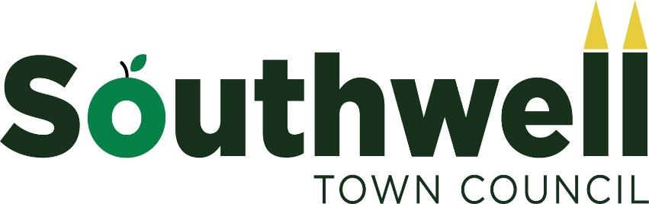

Asset Management Policy

1 Purpose and Context
The Council has a duty towards the electorate to ensure that its assets are properly managed, controlled and recorded.

2 Policy Statement
The Town Council will maintain a Fixed Asset Register of items of value in excess of £150 which is held in the Council Office. It will be updated annually. A record of assets and their values is required to:

  - Provide information to Councillors as to the assets under their control.
  - Provide Information for decision making purposes.
  - Provide information for external reporting, insurance and audit purposes.

The method of fixed asset valuation for first registration on the asset register is at acquisition cost. Meaning that once recorded in the asset register, the recorded value of the asset will not change from year to year until disposal. Commercial concepts of deprecation, impairment adjustments, and revaluation are not required for this method of asset valuation.

3 The Town Council’s Fixed Asset Register contains the following information:
3.1Description of the asset including date acquired.
  - Location of the asset.
3.3Disposal or amount received.
3.4Reason for disposal
3.5Replacement insurance value
3.6Market Value (where appropriate)

Financing of New Assets
It is important that the Council considers the creation and maintenance of new assets. Once identified, any new assets will be financed from a number of sources including: the precept, earmarked reserves, grants, sponsorship and borrowing.

5 Maintenance
Assets will be inspected regularly and maintained to a satisfactory standard.

6 Disposal
The authority to dispose of assets either by destroying, selling them or otherwise, will lie with the Town Council. Any revenue obtained from the disposal of an asset will in normal circumstances be credited to the cost centre which originally purchased the asset.
The Clerk, with a letter to the Chair, to authorise disposals up to £250.
Governance & Finance Committee to authorise disposals between £251 - £1,000.
Full Council authorise all disposals over £1,000.

